**Standard Work - Mobile App Demo Mode**

Version 1.0



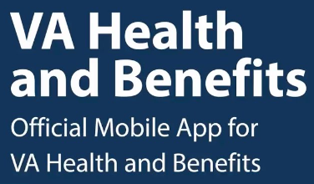

| **Version** | **Author** | **Date** | **Comment** |
| --- | --- | --- | --- |
| 1.0 | Adam Bischoff | 3/16/2023 | Initial Creation |
|  |  |  |  |
|  |  |  |  |
|  |  |  |  |

**Purpose:**

The VA Health and Benefit App’s Demo Mode mode provides a safe and non-productionalized environment for users to interact and engage with the app’s navigation, functionality, features, and designs.

Demo mode is set up with a single user that is not tied to any production test account and allow users to access all of the app’s latest offerings. Users can complete actions such as submitting a secure message or a prescription refill to experience the entire user journey without impacting other systems or teams.

Demo users should use the latest version of the app in order to experience the latest version of demo mode. Work in progress items that the VA Health and Benefits App Team is working on will not appear in demo mode until it is released into production.

**Password:** Zhuzh-it

**Contacts:**

* Team - Ad Hoc Llc.
* VA PO - Chris Johnston
* Ad Hoc Group Product Manager - Matt Hall

**Steps to Access Demo Mode**

1. Download or update existing app to the latest version (any device)
   1. [Apple App Store Link](https://apps.apple.com/us/app/va-health-and-benefits/id1559609596)
   2. [Google Play Store Link](https://play.google.com/store/apps/details?id=gov.va.mobileapp&hl=en_US&gl=US)
2. Click the VA Health and Benefits Logo 21 times
3. Enter the Password and click demo button
4. Screen is updated with a Demo Mode bar on the home screen
5. Click Sign In button
6. Demo user is not at the home page of the mobile app and can explore

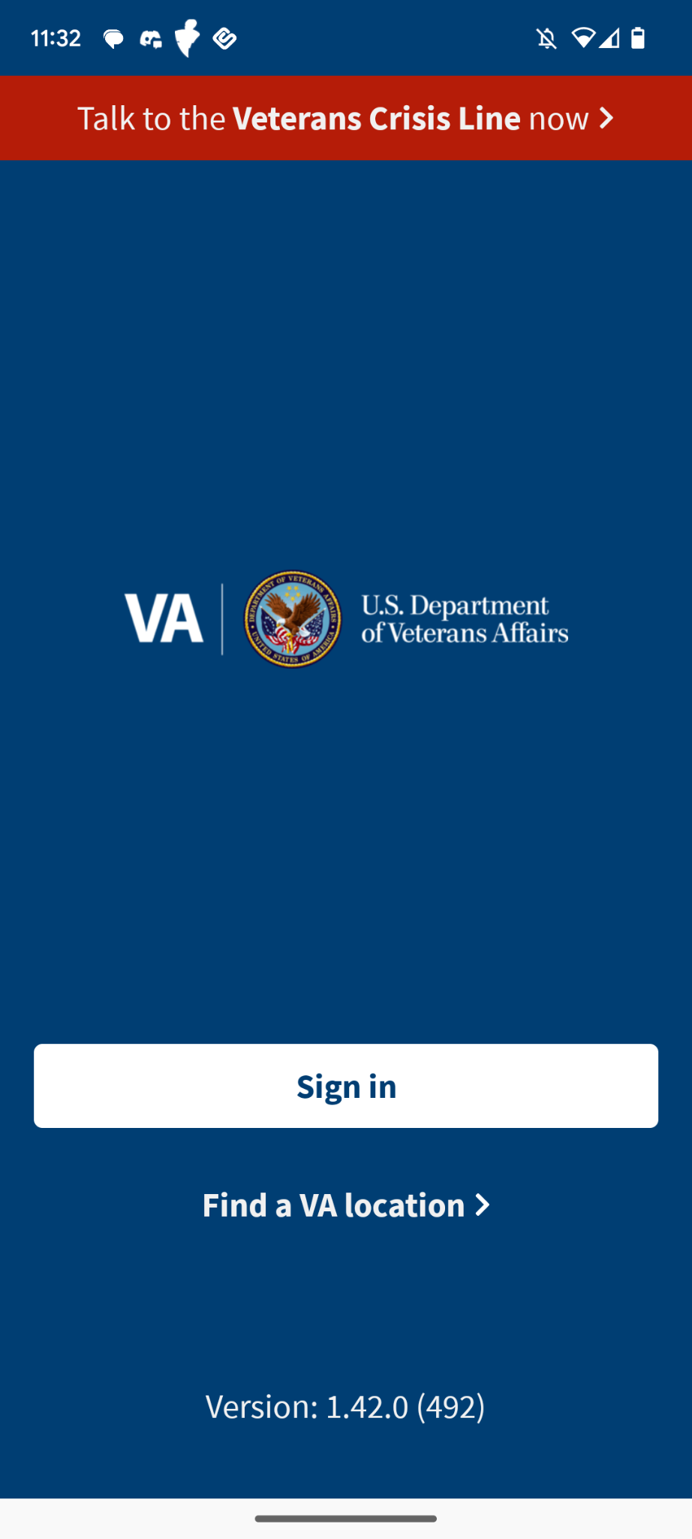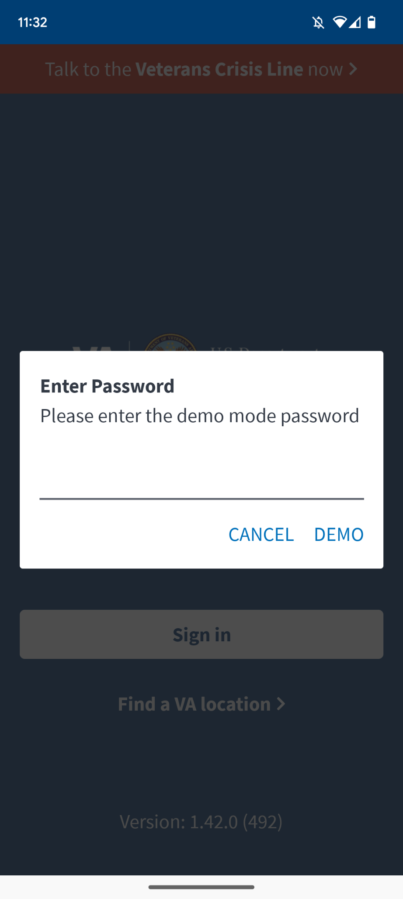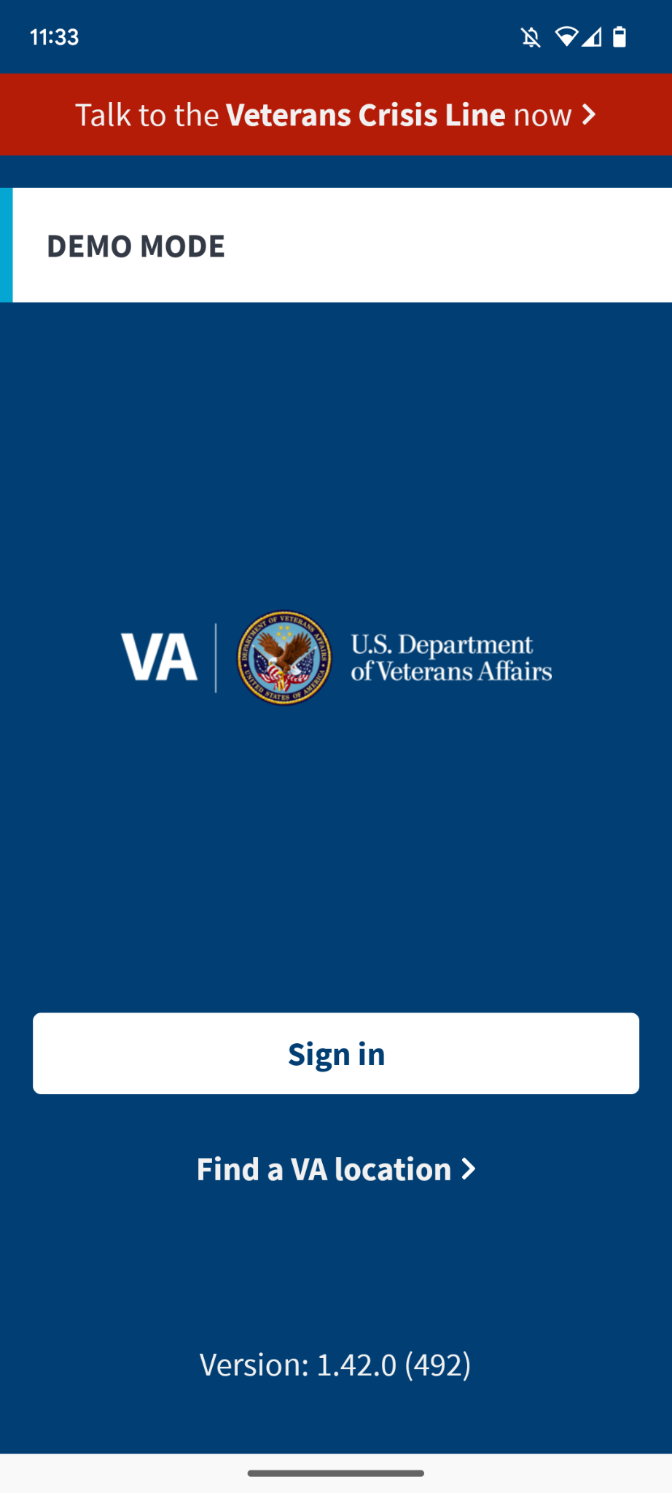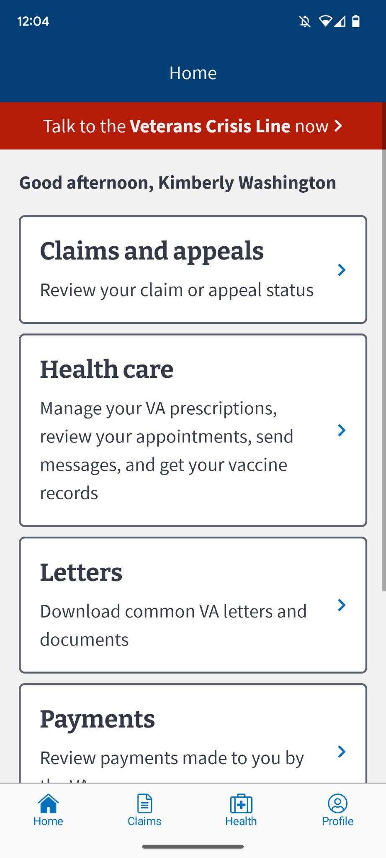

**Troubleshooting:**

* **Demo Mode’s password is not working**
  + Case sensitive and space sensitive - review password entered
  + Mobile app may need to be updated - update the app
  + Demo password has changed - review password on [Demo Mode Gitbhub](https://github.com/department-of-veterans-affairs/va.gov-team/new/master/products/va-mobile-app/demo)
* **RX Prescription does not appear in Demo Mode** 
  + Download the latest version of VA Health and Benefits App
  + Open the app and log into Demo
  + Hard close the app (app switcher then swipe to close it)
  + Open it again and it should be there
  + If not, data may be cached
    - Log into demo mode
    - Go to Settings -> Developer Screen -> Click the Remote Config button
    - Scroll down to the Override Toggle section
    - Click prescription toggle to on
    - Click Apply Overrides
    - Log back into Demo Mode to see Prescriptions in Healthcare section

